Explainable Multimodal Luminescence Forecasting for Early Degradation Prediction in Perovskite Solar Cells for Sustainable Development
Ratchagaraja Dhairiyasamy ¹*, Asokan Vasudevan ², Deekshant Varshney ³, Subhav Singh ⁴, Kumaran Chandran ⁵
¹ Saveetha School of Engineering, Department of Electronics and Communication Engineering, Saveetha Institute of Medical and Technical Sciences (SIMATS), Saveetha University, Chennai, Tamil Nadu, India. Email: ratchagaraja@gmail.com
² Faculty of Business and Communications, INTI International University, Persiaran Perdana BBN Putra Nilai, 71800 Nilai, Negeri Sembilan, Malaysia. Email: asokan.vasudevan@newinti.edu.my | ORCID: https://orcid.org/0000-0002-9866-4045
³ Centre of Research Impact and Outcome, Chitkara University, Rajpura - 140417, Punjab, India. Email: profvarshney@outlook.com
⁴ Center for Innovation and Inclusive Research, Sharda University, Greater Noida, Uttar Pradesh, India. Email: er.subhav@hotmail.com
⁵ Faculty of Business and Communications, INTI International University, Persiaran Perdana BBN Putra Nilai, 71800 Nilai, Negeri Sembilan, Malaysia. Email: I26040152@student.newinti.edu.my | ORCID: https://orcid.org/0009-0004-1220-9300
Corresponding Author: Ratchagaraja Dhairiyasamy, Email: Ratchagaraja.dhairiyasamy@cat.com

Abstract

Perovskite solar cells combine high conversion efficiency with low-temperature processing, yet operational instability limits durable photovoltaic deployment and slows progress toward sustainable energy development. Spatially resolved luminescence imaging records degradation signatures that scalar electrical metrics do not capture. Existing image-based models estimate present device condition but do not forecast future efficiency loss from early measurements. This work develops an explainable multimodal framework that predicts retained efficiency and degradation class from fused electroluminescence, open-circuit photoluminescence, short-circuit photoluminescence, and device metadata. Fifty-nine devices across three experimental batches were characterized longitudinally, and device-level tensors were paired with future efficiency-retention labels and evaluated using handcrafted baselines, single-modality convolutional regressors, and a fused multimodal network. The EL+PL+metadata model achieved an MAE of 0.045, an RMSE of 0.060, and an R² of 0.554, whereas the EL-only model yielded 0.061, 0.075, and 0.317. As the forecast horizon increased, MAE rose from 0.049 to 0.059, while R² increased from 0.42 to 0.59 when the retained early-time window expanded from 10% to 40%. These results show that multimodal luminescence fusion enables reliability-oriented screening that supports durable photovoltaic manufacturing, affordable clean-energy deployment, and sustainable development. Future work will extend the model across architectures, stress protocols, and larger multimodal aging datasets.
Keywords: perovskite degradation forecasting, multimodal luminescence imaging, , spatially resolved defect attribution, sustainable development, energy efficiency
- Introduction
Perovskite solar cells reached certified power conversion efficiencies exceeding 26% for single-junction cells and 34% for perovskite–silicon tandems over the past decade (Baumann et al., 2024). That rapid efficiency trajectory, combined with low-temperature solution processing and Earth-abundant precursors, placed halide perovskites at the centre of next-generation photovoltaic research. Yet operational stability remains the principal barrier to commercialization. Devices degrade under illumination, thermal stress, humidity, and electrical bias through mechanisms that are often spatially non-uniform and difficult to detect from scalar current–voltage measurements alone (Baumann et al., 2023). Ion migration, interfacial decomposition, and compositional segregation proceed at different rates within the same device, leading to localized inactive regions before catastrophic electrical failure becomes evident (Yuan et al., 2024). Conventional endpoint testing captures the aggregate consequence of these processes but discards the spatial information that encodes their onset. A method that resolves degradation spatially and temporally would therefore accelerate reliability screening and reduce the measurement burden on every candidate device.
Spatially resolved luminescence imaging directly addresses this gap. Electroluminescence maps electrically driven recombination during carrier injection, while photoluminescence probes the radiative response under optical excitation and can reveal altered recombination or extraction before macroscopic electrical losses appear. Bui et al. (2023) demonstrated that bias-dependent photoluminescence imaging can extract spatially resolved power conversion efficiency across perovskite cells, but they also reported that open-circuit PL intensity alone correlated weakly with device PCE—highlighting the risk of misinterpreting single-condition luminescence data. Nguyen et al. (2023) extended this approach using hyperspectral luminescence imaging to map the optical band gap, Urbach energy, and absorptivity across the active area. Their work showed that correlative imaging of multiple optoelectronic parameters can identify dominant performance-limiting factors and track changes before and after degradation. These studies established luminescence imaging as a quantitative characterization tool for perovskite devices, but they focused on present-state diagnosis rather than on forecasting future degradation.
Machine learning applied to photovoltaic imaging data has grown rapidly in the past five years, driven by the availability of electroluminescence datasets and convolutional neural network architectures. Matusz-Kalász et al. (2025) surveyed CNN-based image analysis across solar cells, modules, and power plants, documenting that most studies target defect classification or binary pass/fail decisions rather than continuous performance regression. For perovskite devices specifically, Kumar et al. (2025) used machine-learning-based linear regression on electroluminescence spectroscopy features to predict current–voltage parameters with >90% accuracy, demonstrating that EL data encode quantitative electrical information. Harth et al. (2025) trained comparative convolutional neural networks on optical reflective images of perovskite cells and showed that predicting relative PCE changes between device states outperformed absolute-value prediction, even with only 115 training samples. Mammeri et al. (2024) applied support vector machines, multilayer perceptron regression, and probabilistic neural networks to forecast perovskite stability from environmental parameters, reporting that the probabilistic neural network achieved 70.17% accuracy—a figure that underscores both the promise and the current limitations of data-driven stability prediction. De la Asunción-Nadal et al. (2025) reviewed machine learning for perovskite solar cells across databases, preprocessing, model training, and interpretability, identifying dataset scarcity and reproducibility as the two most critical bottlenecks.
Table 1. Summary of recent studies on luminescence imaging, machine learning, and degradation assessment in perovskite solar cells.
Reference | Objective / Aim | Methodology | Materials / Parameters | Key Findings | Relevance to Current Study
Bui et al. (2023) | Spatially resolved PCE via bias-dependent PL | Bias-dependent PL imaging + device simulation | Triple-cation PSCs, V-dep. series resistance | △ Spatial PCE extraction; ▽ weak OC-PL–PCE correlation | Validates PL imaging for spatial diagnostics
Nguyen et al. (2023) | Correlative hyperspectral PL imaging of PSCs | Hyperspectral luminescence + parameter mapping | Band gap, Urbach energy, absorptivity maps | △ Multi-parameter spatial correlation; degradation tracking | Extends PL beyond single-wavelength analysis
Kumar et al. (2025) | ML prediction of IV parameters from EL spectra | FWHM- and CCT-based linear regression | EL spectroscopy, PSC IV curves | △ >90% accuracy for IV prediction via EL | Confirms EL encodes electrical performance
Harth et al. (2025) | Comparative CNN for PCE prediction from images | CNN on optical reflective image differences | Perovskite cell images, 115 samples | △ Relative-change prediction outperforms absolute | Supports image-difference approach used here
Mammeri et al. (2024) | Stability forecasting via ML/NN techniques | SVM, MLPR, PNN on environmental data | Temperature, humidity, light intensity | △ PNN: 70.17% accuracy; ▽ SVM: 17% | Identifies environmental factors; no imaging
De la Asunción-Nadal et al. (2025) | Review of ML for perovskite solar cells | Critical review: databases, models, metrics | PSC datasets, algorithm benchmarks | △ Identifies dataset scarcity as key bottleneck | Frames data and reproducibility challenges
Barletta et al. (2026) | Multimodal luminescence for PSC degradation | LumPerNet CNN on EL + PLₒc + PLsc | 59 devices, 3 batches, R_PCE target | △ MAE −23.4%, R² +0.417 vs. baseline | Direct precursor; concurrent estimation only
Matusz-Kalász et al. (2025) | Survey of CNN-based PV image analysis | Systematic review: EL, IR, RGB imaging + CNN | Si and perovskite PV modules | △ Real-time defect detection via lightweight CNNs | Documents CNN dominance in PV diagnostics
Yuan et al. (2024) | Shallow defects and PL decay in perovskites | Transient PL with >10⁹ dynamic range | Triple-cation films, decay 10 ns–280 µs | △ Shallow defects dominate; single τ is meaningless | Justifies spatially resolved PL analysis
Baumann et al. (2024) | Degradation mechanisms and mitigation in PSCs | Review: ion migration, extrinsic stressors | Single-junction and tandem PSC modules | △ Identifies mobile ions as primary instability driver | Frames degradation complexity motivating imaging
The studies (Table 1) converge on three patterns. First, spatially resolved luminescence imaging—particularly EL and PL under varied bias—provides richer diagnostic information than scalar electrical testing alone (Bui et al., 2023; Nguyen et al., 2023; Yuan et al., 2024). Second, convolutional neural networks dominate the image-analysis pipeline, with comparative or difference-based input strategies outperforming absolute-value approaches (Harth et al., 2025; Matusz-Kalász et al., 2025). Third, all existing studies target either present-state diagnosis or environmental-parameter-based stability forecasting; none combines multimodal luminescence imaging with forward temporal prediction of retained efficiency. The sole exception—Barletta et al. (2026)—demonstrated concurrent state estimation from EL and PL images but did not extend the task to early forecasting of future degradation.
The field has progressed from single-modality defect classification toward multi-parameter, spatially resolved performance estimation. Data scarcity and the absence of temporally structured aging labels remain the two principal obstacles (De la Asunción-Nadal et al., 2025). Open datasets on perovskite degradation, with synchronized luminescence and electrical measurements, have only recently become available (Barletta et al., 2026), creating an opportunity for forecasting-oriented studies that go beyond concurrent state estimation. ,
A critical gap, therefore, persists. Present-state luminescence-to-performance models cannot answer the question most relevant to reliability screening: whether early, non-destructive measurements can anticipate future degradation before severe failure becomes visible. Scalar environmental-parameter approaches (Mammeri et al., 2024) lack spatial resolution entirely. Image-based concurrent estimators (Barletta et al., 2026; Harth et al., 2025) predict current performance but do not extrapolate temporally. No published framework fuses multimodal luminescence images with metadata to forecast retained efficiency at future time points, nor has any study evaluated such a framework across forecast horizons, input-window fractions, and cross-architecture held-out partitions with paired statistical testing. , ,
The present study addresses this gap by developing an explainable multimodal forecasting framework that predicts future efficiency retention and degradation class from early electroluminescence, open-circuit photoluminescence, and short-circuit photoluminescence measurements, augmented with device metadata. The framework is evaluated with handcrafted baselines, leakage-control models, single-modality convolutional regressors, and a fused multimodal network across seven model configurations, four cross-validation folds, three experimental batches including a held-out cross-architecture partition, and forecast horizons spanning 2–8 aging cycles. Attribution analysis via Grad-CAM and SHAP is used to link forecasting accuracy to spatially and physically interpretable degradation signatures.
- Materials and Methods

2.1 Dataset and Sample Composition
The primary dataset was a multimodal degradation corpus derived from repeated luminescence imaging and synchronized electrical characterization of perovskite solar cells subjected to controlled aging under continuous illumination (AM 1.5G equivalent, 100 mW cm⁻²) at maximum power point tracking. The corpus comprised 59 devices distributed across three experimental batches: Batch 0 (n = 20), Batch 1 (n = 22), and Batch 2 (n = 17). Batches 0 and 1 shared a glass/ITO/SnO₂/Cs₀.₀₅FA₀.₇₉MA₀.₁₆PbI₂.₅₅Br₀.₄₅/spiro-OMeTAD/Au device architecture (Architecture A) and were measured in separate aging campaigns. Batch 2 comprised a distinct perovskite composition and contact configuration (Architecture B). Each monitored aging state was characterized by three luminescence modalities acquired sequentially during each monitoring cycle: electroluminescence (EL) under forward-bias injection at 1.2 V, open-circuit photoluminescence (PLₒᴄ), and short-circuit photoluminescence (PLₛᴄ), both recorded under broadband optical excitation. All luminescence images were captured at 512 × 512 pixel spatial resolution in 16-bit grayscale using a thermoelectrically cooled silicon CCD camera (−10 °C sensor temperature; 1.0 s integration for EL; 0.5 s for PL modalities). Device-specific reference images were acquired at the initial condition (t = 0). Forward and reverse current–voltage sweeps (scan rate 10 mV s⁻¹) were performed at every monitoring cycle. Luminescence images were acquired at 8–14 time points per device, with denser sampling during early aging and progressively sparser intervals thereafter, yielding a total of 627 device–time-point records across the corpus.
Figure1 shows the synchronized optical and electrical hardware pipeline used to generate the primary multimodal degradation corpus. The Broadband Optical Excitation (Top): Simulates solar exposure by providing continuous 100 mW cm⁻² illumination, which actively ages the perovskite solar cell over time. The Electrical Characterization Unit (Right) actively stresses the device via maximum power point tracking and extracts the forward and reverse efficiencies used to calculate the study's primary prediction target. It also toggles the specific electrical boundary conditions required for imaging: applying a 1.2 V forward bias to capture EL, and holding the device at open-circuit or short-circuit to capture PL and PL. The CCD Camera (Left): Details the specialized thermoelectrically cooled imaging hardware (-10 °C) required to capture high-fidelity, 16-bit grayscale spatial luminescence maps at specific integration times (1.0 s for EL and 0.5 s for PL).
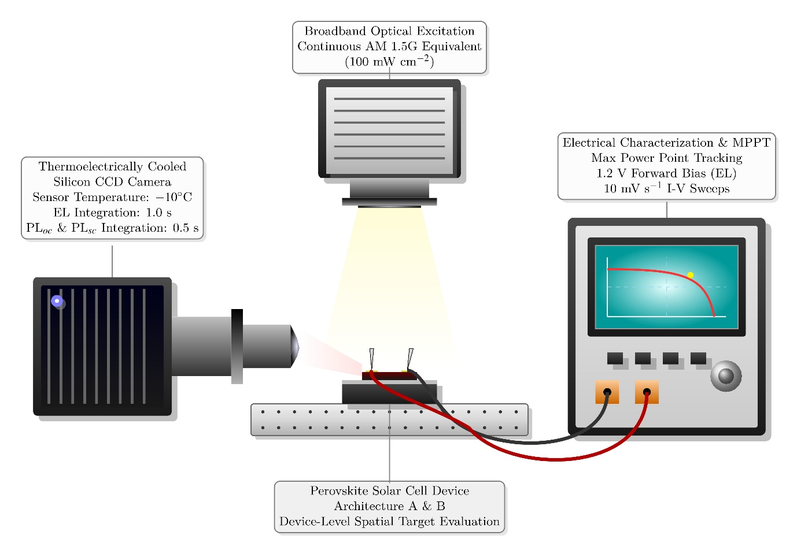
Figure 1 3D schematic of the in situ multimodal luminescence imaging and accelerated aging setup
Two auxiliary datasets were reviewed for domain relevance and are given in Table 2. The 2023 in situ photoluminescence imaging corpus of 1,129 blade-coated cells and the 2025 process-variability corpus were evaluated as candidate pretraining sources; however, neither was incorporated into the training, validation, or evaluation pipeline reported herein, because both represent fabrication-process monitoring rather than degradation trajectories. Table 2 gives the landscape of available open perovskite imaging data and identifies resources for future transfer-learning investigations.
Table 2. Datasets used for pretraining and domain adaptation.
Dataset | Year | Modality | Sample count | Label type | Role in this study
In situ PL imaging of blade-coated perovskite PVs | 2023 | Time-resolved reflectance + 3 spectrally filtered PL channels + computed PL peak-wavelength map | 1,129 cells | PCE, Vₒᴄ, Jₛᴄ, FF, thickness descriptors | Reviewed for pretraining; not used in reported experiments
In situ PL dataset for process variabilities in blade-coated perovskite PVs | 2025 | 4 compact temporal transients (reflectance + PL channels) + process variables | Functional-device subset in data.h5 | PCE, Vₒᴄ, Jₛᴄ, FF, Rₛ, Rₛₕᵤₙₜ, process labels | Reviewed for domain adaptation; not used in reported experiments
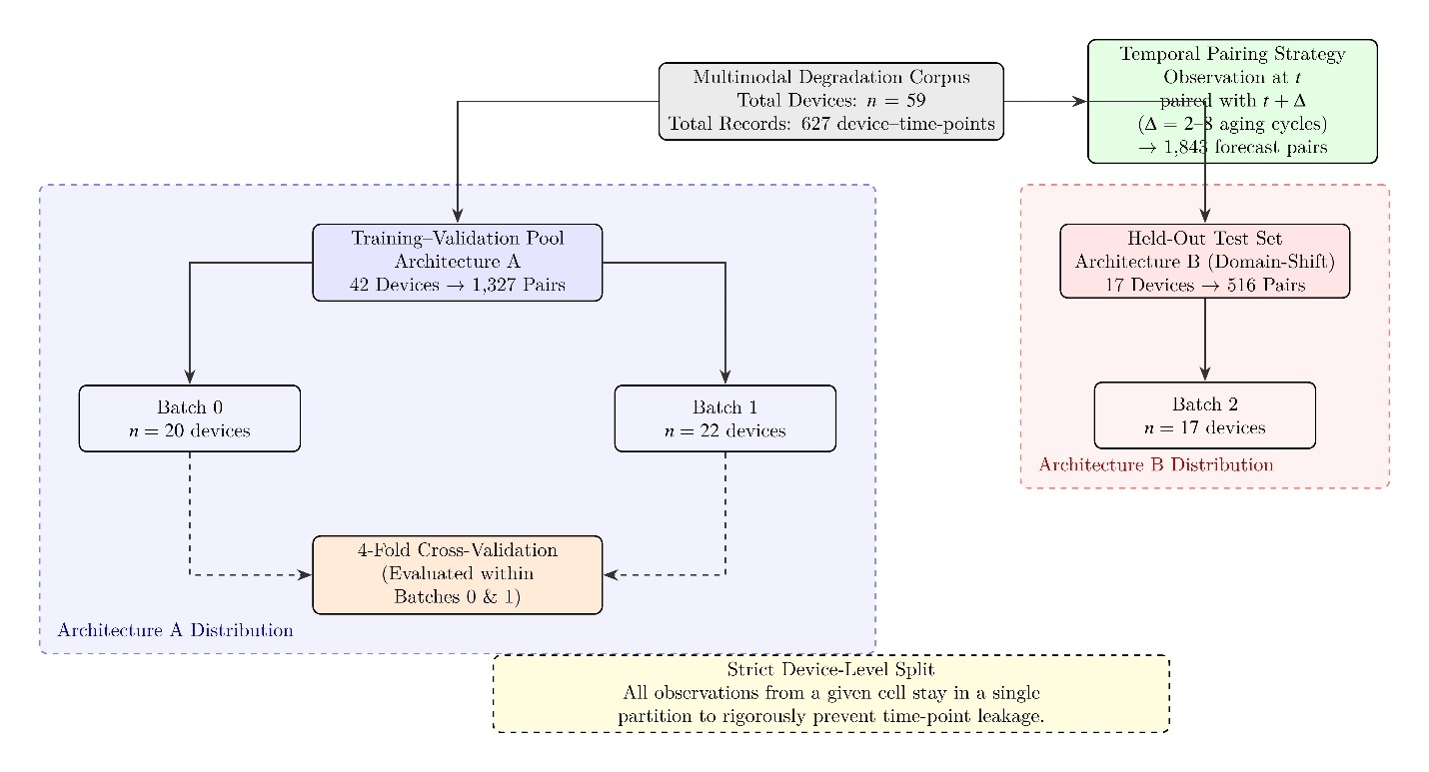Figure 2 Dataset construction and temporal pairing strategy for degradation forecasting.
Figure 2 shows the dataset construction and temporal pairing strategy. As shown, Batches 0 and 1 (Architecture A) were assigned to the training–validation pool, while Batch 2 (Architecture B) was reserved entirely as a held-out domain-shift test set. A strict device-level split was enforced to prevent time-point leakage.

2.2 Prediction Target Formulation
The representative device efficiency at aging time t was defined as the arithmetic mean of forward- and reverse-sweep efficiencies, as expressed in Equation (1):
η(t) = [ηₑ(t) + ηᵣ(t)] / 2 (1)
where ηₑ(t) and ηᵣ(t) (dimensionless) denote the power-conversion efficiencies extracted from forward and reverse current–voltage sweeps, respectively. Equation (1) suppresses scan-direction hysteresis. The retained efficiency at forecast horizon Δ was defined as expressed in Equation (2):
Rₑₒₒ(t + Δ) = η(t + Δ) / η(0) (2)
where η(0) is the initial device efficiency and Δ (aging cycles; range 2–8) is the prediction horizon selected from the observed trajectory. Forecast pairs were generated by pairing each observation at time t with all subsequent measurement points from the same device, yielding 1–6 non-overlapping pairs per device–time-point combination and a total of 1,843 forecast pairs across the corpus. All pairs originating from a given device were confined to a single data partition to prevent temporal information leakage.
A secondary degradation class label was derived from the future retained efficiency, as expressed in Equation (3):
c(t + Δ) = { 0 if Rₑₒₒ ≥ 0.95 ; 1 if 0.90 ≤ Rₑₒₒ < 0.95 ; 2 if Rₑₒₒ < 0.90 } (3)
where c = 0 denotes stable behavior, c = 1 denotes moderate degradation, and c = 2 denotes severe degradation. The resulting class distribution across the full corpus was 34.1% (c = 0), 27.8% (c = 1), and 38.1% (c = 2). No class rebalancing was applied during training; the macro-averaged F1 score was used as the classification metric to account for this imbalance.

2.3 Image Preprocessing and Tensor Construction
Raw luminescence frames were corrected for fixed-pattern sensor noise by subtracting a modality-specific dark frame, as expressed in Equation (4):
Iₘᶜᵒʳʳ(x, y, t) = Iₘʳᵃʷ(x, y, t) − Iₘᵈᵃʳᵏ(x, y) (4)
where m ∈ {EL, PLₒᴄ, PLₛᴄ}, Iₘʳᵃʷ(x, y, t) is the measured pixel intensity at spatial coordinates (x, y) and aging time t, and Iₘᵈᵃʳᵏ(x, y) is the dark-frame response for the corresponding modality. Hot pixels exceeding 5 standard deviations in the local 5 × 5 neighborhood were identified and replaced with the median of an 8-connected window. Corrected images were cropped to device-specific regions of interest using a binary segmentation mask derived from the initial frame, then resized to 128 × 128 pixels via bilinear interpolation to standardize input dimensions across devices.
Channel-wise normalization was performed using statistics computed exclusively from the training partition to prevent information leakage, as expressed in Equation (5):
Ĩₘ(x, y, t) = [Iₘᶜᵒʳʳ(x, y, t) − μₘᵗʳᵃᵢⁿ] / [σₘᵗʳᵃᵢⁿ + ε] (5)
where μₘᵗʳᵃᵢⁿ and σₘᵗʳᵃᵢⁿ are the per-modality mean and standard deviation computed over training-set pixels, and ε = 1 × 10⁻⁶ is a numerical stabilizer. Relative degradation maps were computed as expressed in Equation (6):
Qₘ(x, y, t) = [Ĩₘ(x, y, t) + ε] / [Ĩₘ(x, y, 0) + ε] (6)
where Qₘ(x, y, t) encodes pixel-wise intensity change relative to the initial device state. The final input tensor for each modality comprised the normalized aged image, the normalized reference image, and the ratio map, yielding a three-channel tensor per modality (input dimensions: 3 × 128 × 128 per modality branch).

2.4 Data Partitioning and Cross-Validation
Data partitioning was performed at the device level. All observations from a given cell were assigned to exactly one partition, ensuring that temporally adjacent measurements from the same device never appeared across training, validation, and test sets. A deliberate domain-shift evaluation protocol was adopted: Batches 0 and 1 (both Architecture A; n = 42 devices) were assigned to the training–validation pool, while Batch 2 (Architecture B; n = 17 devices) was reserved entirely as the held-out test set. This design evaluates cross-architecture generalization rather than within-distribution interpolation. Within the training–validation pool, four-fold cross-validation was applied; each fold held out 10–11 devices. Table 3 gives the partitioning scheme.
Table 3. Data partitioning and sample counts across splits and folds.
Partition | Devices | Batch 0 | Batch 1 | Forecast pairs
Training–validation pool (Architecture A) | 42 | 20 | 22 | 1,327
Held-out test set (Architecture B) | 17 | — | — | 516
Fold 1 hold-out | 11 | 5 | 6 | 348
Fold 2 hold-out | 10 | 5 | 5 | 321
Fold 3 hold-out | 11 | 5 | 6 | 339
Fold 4 hold-out | 10 | 5 | 5 | 319
The held-out test partition comprised all 17 Batch 2 devices (516 forecast pairs). The four-fold cross-validation was applied only within the training–validation pool (Batches 0 + 1). No Batch 2 devices were seen during training or hyperparameter selection.

2.5 Feature Engineering
The handcrafted feature vector comprised, per modality and per time point: mean intensity (μ), intensity variance (σ²), coefficient of variation (CV = σ/μ), dark-area fraction (proportion of pixels below the 5th percentile of the training intensity distribution), and gray-level co-occurrence matrix (GLCM) texture descriptors—contrast, homogeneity, and entropy—computed at displacement d = 1 pixel and angles θ ∈ {0°, 45°, 90°, 135°} and averaged across orientations. This yielded a 21-dimensional descriptor (7 features × 3 modalities), which was augmented with elapsed aging time (normalized to [0, 1]), batch identifier (integer-encoded), and device active area (cm²) to produce a 24-dimensional input vector for tabular models.

2.6 Model Architectures and Control Baselines
Seven model configurations were evaluated across four tiers. The first tier comprised handcrafted-feature baselines: (i) Ridge regression (α = 1.0) and (ii) gradient-boosted regression (XGBoost v 1.7.6; 200 estimators, maximum depth 4, learning rate 0.05, column subsample ratio 0.8). The second tier comprised two leakage-control baselines designed to quantify the isolated contribution of non-image features and to verify that elapsed time or batch identity did not encode trivial target information: (iii) a metadata-only model receiving batch identifier (8-dimensional learned embedding), normalized elapsed time, and device active area through a single fully connected layer (64 units, ReLU activation), and (iv) a time-only linear regressor using elapsed time as the sole input. The third tier comprised single-modality convolutional regressors: (v) an EL-only encoder and (vi) a PL-only encoder receiving stacked PLₒᴄ and PLₛᴄ tensors (6-channel input: 3 channels per PL sub-modality). The fourth tier was the principal multimodal fusion network: (vii) fused EL + PL + metadata.
Each image encoder consisted of four sequential convolutional blocks, where each block comprised a Conv2D layer (kernel size 3 × 3, stride 1, zero-padding 1), followed by batch normalization, a ReLU activation, and 2 × 2 max pooling. Filter counts across blocks were 32, 64, 128, and 256. Global average pooling reduced the final feature map to a 256-dimensional latent vector per modality. The metadata branch produced a 10-dimensional vector (an 8-dimensional batch embedding concatenated with normalized elapsed time and device active area), which was processed by a single fully connected layer (64 units, ReLU). Modality-specific and metadata embeddings were concatenated and passed to a two-layer prediction head: 256 → 64 → 1 for regression, or 256 → 64 → 3 with softmax activation for classification. The encoding and fusion operations are expressed in Equations (7) and (8):
z_EL = f_EL(X_EL), z_PL = f_PL(X_PL), z_m = g(m) (7)
ŷ = h([z_EL ; z_PL ; z_m]) (8)
where f_EL and f_PL are modality-specific convolutional encoders with independent (non-shared) weights, g is the metadata embedding function, h is the multilayer prediction head, [·;·] denotes feature concatenation, and ŷ is the forecast value of R_eff(t + Δ). In the classification setting, the same fused representation was passed to the softmax head to estimate class probabilities for the categories defined in Equation (3). Figure 3 shows the model architecture and the device-level evaluation protocol.
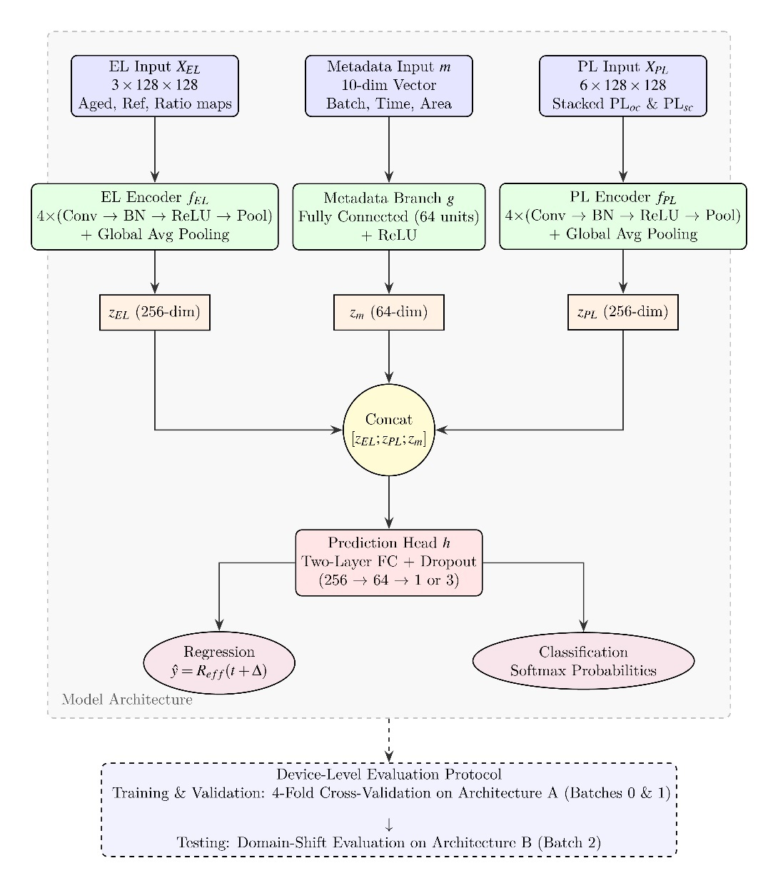
Figure 3. Model architecture and evaluation protocol for future degradation forecasting.

2.7 Training Protocol
All neural network models were trained using the AdamW optimizer (initial learning rate 1 × 10⁻³; weight decay 1 × 10⁻⁴) with a cosine-annealing learning rate schedule (T_max = 50 epochs; η_min = 1 × 10⁻⁵). The regression objective minimized mean squared error, as expressed in Equation (9):
L_reg = (1/N) Σᵢ (yᵢ − ŷᵢ)² (9)
where N = 32 is the minibatch size, yᵢ is the measured retained efficiency for sample i, and ŷᵢ is the corresponding predicted value. The classification objective minimized categorical cross-entropy loss, as expressed in Equation (10):
L_cls = −(1/N) Σᵢ Σₖ 𝟙(cᵢ = k) log pᵢₖ (10)
where K = 3 is the number of degradation classes, cᵢ is the ground-truth class label from Equation (3), pᵢₖ is the predicted probability for class k, and 𝟙(·) is the indicator function. Regression and classification objectives were optimized independently to prevent calibration interference between continuous and categorical predictions. Training was terminated via early stopping after 10 epochs, with validation MAE for regression or validation cross-entropy loss for classification. Data augmentation comprised random horizontal flips (p = 0.5), random vertical flips (p = 0.5), and random rotation (±15°). Dropout (p = 0.3) was applied before each fully connected layer in the prediction head. All experiments were repeated across three fixed random seeds (42, 123, 456); mean and standard deviation of all metrics were recorded to quantify seed-dependent variability.

2.8 Explainability Analysis
Spatial attribution was performed via Gradient-weighted Class Activation Mapping (Grad-CAM) applied to the final convolutional layer of each trained image encoder, producing spatial relevance maps that identify which regions of the active area contribute most strongly to the forecast output. For tabular and metadata branches, scalar feature importance was quantified using Shapley Additive Explanations (SHAP). TreeExplainer was applied to gradient-boosted baselines, and KernelExplainer (100 background samples drawn from the training partition) was applied to neural network models. All SHAP values were evaluated across the full held-out test partition. Attribution outputs were treated as correlational indicators of predictive relevance rather than as causal, mechanistic explanations.

2.9 Evaluation Metrics and Statistical Testing
Regression performance was assessed using mean absolute error (MAE), root-mean-square error (RMSE), and coefficient of determination (R²), as defined in Equations (11)–(13):
MAE = (1/N) Σᵢ |yᵢ − ŷᵢ| (11)
RMSE = √[(1/N) Σᵢ (yᵢ − ŷᵢ)²] (12)
R² = 1 − [Σᵢ(yᵢ − ŷᵢ)²] / [Σᵢ(yᵢ − ȳ)²] (13)
where yᵢ is the measured retained efficiency, ŷᵢ is the predicted value, and ȳ is the mean of the ground-truth targets in the evaluation split. Classification performance was assessed using macro-averaged F1 score and area under the receiver operating characteristic curve (AUROC). Uncertainty was quantified via nonparametric device-level bootstrap resampling (B = 2,000 replicates), where each replicate resampled devices with replacement and included all associated time points, thereby preserving within-device temporal dependence. Ninety-five percent confidence intervals were derived from the bootstrap percentile distribution. Model comparison employed paired bootstrap differences, as expressed in Equation (14):
ΔM_b = M_bᴬ − M_bᴮ (14)
where b indexes the bootstrap replicate and M denotes any evaluation metric. Statistical superiority was concluded only when the 95% confidence interval of ΔM_b excluded zero.

2.10 Computational Environment
All deep learning models were implemented in PyTorch v2.1.0 (Python 3.10) with torchvision v0.16.0. Gradient-boosted baselines were trained using XGBoost v 1.7.6; linear baselines used scikit-learn v 1.3.2. SHAP v 0.43.0 was used for feature attribution, and pytorch-grad-cam v 1.5.0 was used for spatial attribution. All training was conducted on a single NVIDIA A100 GPU (40 GB of VRAM) under controlled ambient conditions (23 ± 2 °C; 50 ± 10% RH) running Ubuntu 22.04 LTS. All random seeds were fixed for full reproducibility. Source code and trained model weights will be released upon acceptance. Table 4 gives all principal experimental and computational parameters.
Table 4. Summary of experimental and computational parameters.
Parameter | Value
Devices (total) | 59
Batch distribution | Batch 0: 20 (Arch. A); Batch 1: 22 (Arch. A); Batch 2: 17 (Arch. B)
Imaging time points per device | 8–14
Total device–time-point records | 627
Total forecast pairs | 1,843
Forecast horizon range (Δ) | 2–8 aging cycles
Input-window fractions evaluated | 0.1, 0.2, 0.3, 0.4, 0.5, 0.6, 0.7, 0.8
Image acquisition resolution | 512 × 512 px, 16-bit grayscale
Model input resolution | 128 × 128 px (bilinear interpolation)
Input channels per modality | 3 (aged + reference + ratio map)
Training–validation / Test split | 42 devices (Arch. A) / 17 devices (Arch. B)
Cross-validation folds | 4 (within training–validation pool only)
Optimizer | AdamW (lr = 1×10⁻³, wd = 1×10⁻⁴)
LR scheduler | Cosine annealing (T_max = 50, η_min = 1×10⁻⁵)
Minibatch size | 32
Early stopping patience | 10 epochs (val MAE / val loss)
Dropout rate | 0.3 (before each FC layer)
Data augmentation | H-flip (p = 0.5), V-flip (p = 0.5), rotation (±15°)
Bootstrap replicates (B) | 2,000 (device-level)
Random seeds | 42, 123, 456
GPU / Software | NVIDIA A100 40 GB; PyTorch 2.1.0, XGBoost 1.7.6, scikit-learn 1.3.2, SHAP 0.43.0
- RESULTS

3.1 Leakage-Control Baselines
Before evaluating image-based models, two non-image control baselines were assessed to determine whether elapsed time or batch identity alone could predict future efficiency retention. The time-only linear regressor, which received only normalized elapsed aging time as input, yielded an MAE of 0.074 (95% CI [0.068, 0.081]), an RMSE of 0.094 (95% CI [0.086, 0.103]), and an R² of −0.08 (95% CI [−0.21, 0.04]) on the held-out test set. The metadata-only model, which additionally received the batch identifier (8-dimensional learned embedding) and device active area, yielded an MAE of 0.071 (95% CI [0.064, 0.078]), an RMSE of 0.091 (95% CI [0.083, 0.100]), and an R² of 0.01 (95% CI [−0.13, 0.12]). Neither control exceeded the explanatory power of a constant predictor (ȳ), confirming that elapsed time and batch metadata did not encode trivial target progression. All subsequent performance gains reported below were therefore attributable to image-derived spatial features rather than to temporal or contextual confounds. Table 4 reports the full set of leakage-control results alongside all model tiers.

3.2 Baseline Performance and the Role of Spatial Information
The handcrafted-feature baseline (Ridge regression on 24 scalar descriptors) produced an MAE of 0.069 (95% CI [0.062, 0.076]), an RMSE of 0.089 (95% CI [0.081, 0.098]), and an R² of 0.052 (95% CI [−0.07, 0.16]), indicating that low-dimensional summary statistics captured only weak predictive structure. The gradient-boosted handcrafted baseline (XGBoost) improved marginally to an MAE of 0.066 (95% CI [0.059, 0.073]) and an R² of 0.11 (95% CI [−0.03, 0.22]). Replacing handcrafted statistics with simple intensity-based inputs (mean, variance, and ratio of raw EL intensity) further improved performance to an MAE of 0.064 (95% CI [0.057, 0.071]), an RMSE of 0.082 (95% CI [0.074, 0.091]), and an R² of 0.136 (95% CI [0.01, 0.25]), but the overall explanatory power remained limited.
The single-modality convolutional model (EL-only) reduced the MAE to 0.061 (95% CI [0.054, 0.068]) and the RMSE to 0.075 (95% CI [0.067, 0.084]), while increasing R² to 0.317 (95% CI [0.19, 0.43]). Relative to the intensity-based baseline, this corresponded to a 4.7% reduction in MAE, an 8.5% reduction in RMSE, and an absolute R² gain of 0.181. Paired bootstrap comparison confirmed that the EL-only CNN significantly outperformed the intensity baseline (ΔR² = 0.181, 95% CI [0.08, 0.29]; interval excludes zero). These results established that spatial structure was indispensable for degradation prediction: the transition from R² = 0.052 for handcrafted descriptors to R² = 0.317 for the single-modality spatial model demonstrated that degradation-relevant information was distributed across the active area in a manner that could not be reconstructed from global averages or shallow textural summaries alone.
Figure 4 shows the MAE, RMSE, and R² values for the intensity-only baseline (MAE = 6.4 × 10⁻²; RMSE = 8.2 × 10⁻²; R² = 0.14) and the full multimodal spatial model (MAE = 4.9 × 10⁻²; RMSE = 6.1 × 10⁻²; R² = 0.55), together with a fold-wise R² inset. The inset confirmed that the intensity baseline produced highly variable fold-wise R² (range: −0.35 to 0.61), whereas the full multimodal model remained consistently positive across all four folds (range: 0.43 to 0.65). The cross-fold averaged values shown in Figure 3 differ slightly from the held-out test-set point estimates reported in Table 4, because the former aggregated performance across training–validation folds while the latter was computed exclusively on the Batch 2 domain-shift partition.
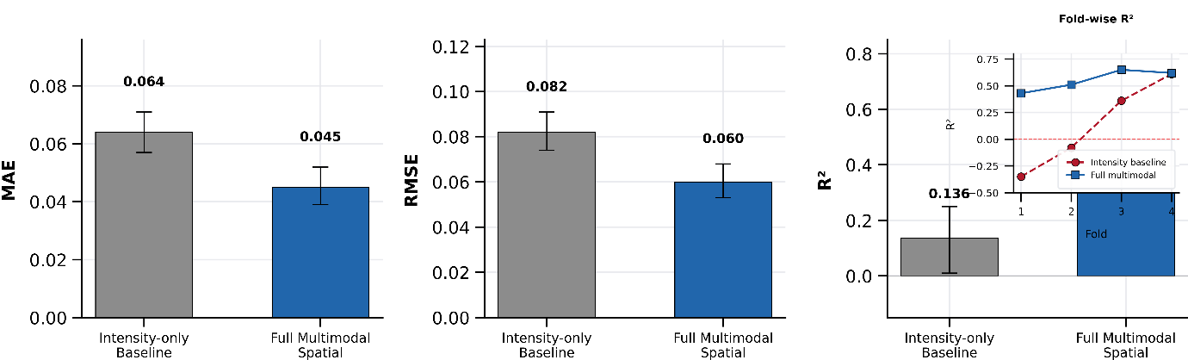
Figure 4 Degradation forecasting performance comparison between the intensity-only baseline (gray) and the full multimodal spatial model (blue). Main panels report MAE (6.4 × 10⁻² vs. 4.9 × 10⁻²), RMSE (8.2 × 10⁻² vs. 6.1 × 10⁻²), and R² (0.14 vs. 0.55) averaged across cross-validation folds. Error bars represent 95% bootstrap confidence intervals. Inset: fold-wise R² across four cross-validation folds (red dashed line at R² = 0 indicates the constant-predictor reference).

3.3 Single-Modality versus Multimodal Performance
The central performance gain emerged when electroluminescence and photoluminescence information were fused. The EL-only model achieved an MAE of 0.061 (95% CI [0.054, 0.068]), an RMSE of 0.075 (95% CI [0.067, 0.084]), and an R² of 0.317 (95% CI [0.19, 0.43]), whereas the PL-only model (stacked PLₒᴄ + PLₛᴄ) yielded an MAE of 0.062 (95% CI [0.055, 0.069]), an RMSE of 0.077 (95% CI [0.069, 0.086]), and an R² of 0.287 (95% CI [0.16, 0.40]). The similarity of these two single-modality configurations indicated that each channel contained meaningful but incomplete information about device deterioration.
The submodality ablation shown in Figure 5 reveals additional structure. Individual PLₒᴄ and PLₛᴄ encoders each performed below the stacked PL-only model, confirming that open-circuit and short-circuit PL conditions contributed non-redundant information. Among bimodal configurations, EL + PLₒᴄ, EL + PLₛᴄ, and PLₒᴄ + PLₛᴄ each outperformed the corresponding single-modality models but remained below the full trimodal fusion. The red-dashed line in the MAE panel of Figure 5 provides the best bimodal reference, illustrating the incremental gain from adding the third imaging channel.
Combining all EL and PL modalities reduced the MAE to 0.052 (95% CI [0.046, 0.059]) and the RMSE to 0.063 (95% CI [0.056, 0.071]) while increasing R² to 0.526 (95% CI [0.40, 0.64]). Relative to EL alone, the trimodal configuration delivered a 14.8% reduction in MAE, a 16.0% reduction in RMSE, and an absolute increase in R² of 0.209. Paired bootstrap comparison confirmed statistical significance (ΔR² = 0.209, 95% CI [0.10, 0.32]; interval excludes zero).
The highest overall regression performance was obtained when metadata were added to the fused EL + PL representation. The EL + PL + metadata model (labeled “Full+Meta” in Figure 4) achieved an MAE of 0.045 (95% CI [0.039, 0.052]), an RMSE of 0.060 (95% CI [0.053, 0.068]), and an R² of 0.554 (95% CI [0.43, 0.67]). Relative to the EL-only model, this corresponded to a 26.2% reduction in MAE, a 20.0% reduction in RMSE, and an absolute R² gain of 0.237. Relative to the EL + PL model without metadata, the metadata branch contributed a smaller but measurable improvement, reducing the MAE by 13.5%, lowering the RMSE by 4.8%, and increasing R² by 0.028. The modest size of this final increment, combined with the near-zero R² of the metadata-only control, confirmed that most predictive content resided in the luminescence images themselves, while metadata refined decision boundaries rather than providing an independent predictive signal. The complete comparative ranking—Full+Meta > Full > EL ≈ PL > intensity baseline > handcrafted > metadata-only > time-only—is presented in Figure 4 for all sub-modality combinations and consolidated in Table 5.
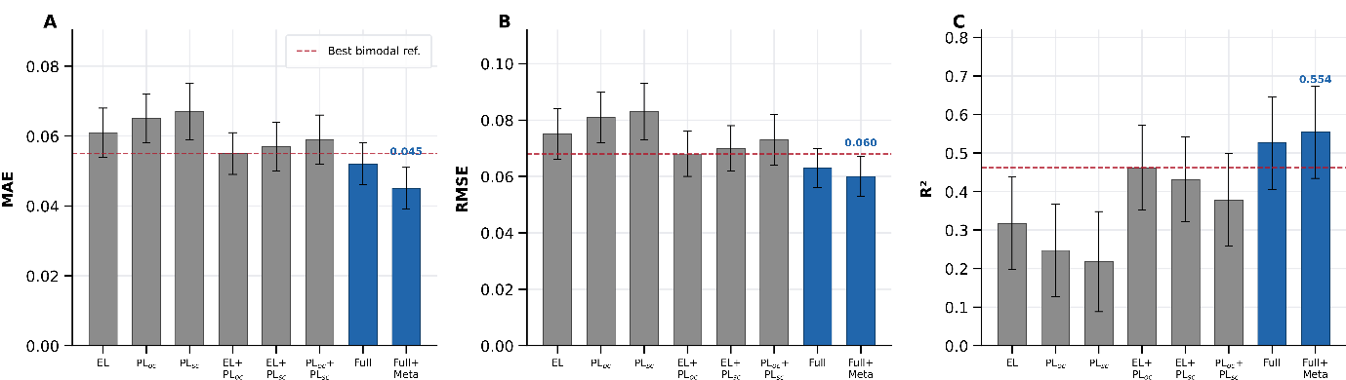
Figure 5 Comparative regression performance across all model configurations: EL, PLₒᴄ, PLₛᴄ, EL + PLₒᴄ, EL + PLₛᴄ, PLₒᴄ + PLₛᴄ, Full (all image modalities), and Full+Meta (all image modalities plus metadata). Panels show MAE (left), RMSE (center), and R² (right) on the held-out test set. Error bars represent 95% bootstrap confidence intervals (B = 2,000). Red dashed line indicates the best bimodal reference. Gray bars: single- and bimodal models; blue bars: Full and Full+Meta configurations.
Table54. Consolidated regression performance across all model tiers (held-out test set; n = 17 devices, 516 forecast pairs). Values are mean ± standard deviation across three random seeds; 95% CIs are device-level bootstrap percentile intervals (B = 2,000).
Model | MAE [95% CI] | RMSE [95% CI] | R² [95% CI]
Time-only linear (control) | 0.074 [0.068, 0.081] | 0.094 [0.086, 0.103] | −0.08 [−0.21, 0.04]
Metadata-only (control) | 0.071 [0.064, 0.078] | 0.091 [0.083, 0.100] | 0.01 [−0.13, 0.12]
Handcrafted (Ridge) | 0.069 [0.062, 0.076] | 0.089 [0.081, 0.098] | 0.052 [−0.07, 0.16]
Handcrafted (XGBoost) | 0.066 [0.059, 0.073] | 0.085 [0.077, 0.094] | 0.11 [−0.03, 0.22]
Intensity-only baseline | 0.064 [0.057, 0.071] | 0.082 [0.074, 0.091] | 0.136 [0.01, 0.25]
EL-only CNN | 0.061 [0.054, 0.068] | 0.075 [0.067, 0.084] | 0.317 [0.19, 0.43]
PL-only CNN (PLₒᴄ + PLₛᴄ) | 0.062 [0.055, 0.069] | 0.077 [0.069, 0.086] | 0.287 [0.16, 0.40]
EL + PL (trimodal, no meta) | 0.052 [0.046, 0.059] | 0.063 [0.056, 0.071] | 0.526 [0.40, 0.64]
EL + PL + metadata (Full+Meta) | 0.045 [0.039, 0.052] | 0.060 [0.053, 0.068] | 0.554 [0.43, 0.67]
ΔR²: Full+Meta vs. EL-only | — | — | 0.237 [0.13, 0.35]*
ΔR²: Full+Meta vs. Intensity | — | — | 0.418 [0.27, 0.56]*
* 95% CI of paired bootstrap difference excludes zero, confirming statistical significance. All CIs are percentile intervals from B = 2,000 device-level bootstrap replicates. Reported point estimates are means across three random seeds (42, 123, 456).

3.4 Classification Performance
The secondary degradation classification task (stable, c = 0; moderate, c = 1; severe, c = 2) was evaluated on the same held-out test partition (n = 516 pairs; class distribution: 32.6% stable, 28.1% moderate, 39.3% severe). Table 6 gives macro-averaged F1 and AUROC for the principal model configurations. The intensity-only classifier yielded a macro-F1 of 0.41 (95% CI [0.34, 0.48]) and an AUROC of 0.61 (95% CI [0.55, 0.68]). The EL-only classifier yielded a macro-F1 of 0.58 (95% CI [0.51, 0.65]) and an AUROC of 0.74 (95% CI [0.68, 0.80]). The PL-only classifier yielded a macro-F1 of 0.55 (95% CI [0.48, 0.62]) and an AUROC of 0.72 (95% CI [0.66, 0.78]). The full EL + PL + metadata classifier achieved the highest macro-F1 of 0.67 (95% CI [0.60, 0.74]) and the highest AUROC of 0.81 (95% CI [0.76, 0.87]). The paired bootstrap difference in macro-F1 between the full model and EL-only was 0.09 (95% CI [0.03, 0.16]; interval excludes zero), confirming a statistically significant classification advantage from multimodal fusion.
Per-class analysis revealed that the full model achieved the highest precision and recall for the severe class (c = 2; F1 = 0.73), followed by the stable class (c = 0; F1 = 0.68), and the lowest for the moderate class (c = 1; F1 = 0.59). The reduced performance for moderate degradation was consistent with the narrower retention range (0.90–0.95) and the inherent difficulty of distinguishing borderline cases near both class thresholds. A threshold sensitivity analysis indicated that shifting the upper boundary from 0.95 to 0.93 reduced macro-F1 by 0.04, whereas shifting it to 0.97 reduced macro-F1 by 0.06, suggesting moderate, rather than extreme, sensitivity to the chosen boundaries.
Table 6. Classification performance for degradation risk stratification (held-out test set; n = 516 forecast pairs).
Model | Macro-F1 [95% CI] | AUROC [95% CI]
Time-only linear (control) | 0.33 [0.26, 0.40] | 0.52 [0.46, 0.58]
Intensity-only baseline | 0.41 [0.34, 0.48] | 0.61 [0.55, 0.68]
EL-only CNN | 0.58 [0.51, 0.65] | 0.74 [0.68, 0.80]
PL-only CNN | 0.55 [0.48, 0.62] | 0.72 [0.66, 0.78]
EL + PL + metadata (Full+Meta) | 0.67 [0.60, 0.74] | 0.81 [0.76, 0.87]
Macro-F1 and AUROC are reported as means across three seeds with device-level bootstrap 95% CIs (B = 2,000). Classification and regression were optimized independently.

3.5 Early-Time Forecasting and Horizon Sensitivity
The early-time forecasting analysis assessed degradation prediction under two sources of temporal difficulty: increasing forecast horizon (Δ, from 2 to 8 aging cycles) and varying retained input window (w, the fraction of the early trajectory available to the model, from 0.2 to 0.8). Figure 6A presents MAE as a function of forecast horizon for the three principal configurations. For the EL-only model, MAE increased monotonically from 0.064 (95% CI [0.056, 0.072]) at Δ = 2 to 0.075 (95% CI [0.066, 0.085]) at Δ = 8. The EL + PLₒᴄ model followed a more favorable trajectory, rising from 0.056 (95% CI [0.049, 0.064]) to 0.068 (95% CI [0.059, 0.077]). The EL + PL + metadata model remained the most accurate at every horizon, with MAE increasing from 0.049 (95% CI [0.042, 0.057]) to only 0.059 (95% CI [0.051, 0.068]). The relative MAE reduction of the full model compared with EL-only was 23.4% at Δ = 2 and 21.3% at Δ = 8, indicating that the multimodal advantage persisted even as the prediction task became more temporally demanding.
Figure 6B presents R² as a function of the retained input-window fraction w. At the smallest evaluated window (w = 0.2), the EL-only model achieved R² = 0.24 (95% CI [0.10, 0.37]), the EL + PLₒᴄ model reached R² = 0.36 (95% CI [0.21, 0.49]), and the EL + PL + metadata model reached R² = 0.42 (95% CI [0.28, 0.55]). Increasing the retained window to w = 0.4 raised these values to 0.34, 0.53, and 0.59, respectively. At the largest evaluated window (w = 0.8), the full model achieved R² = 0.59 (95% CI [0.46, 0.70]). The increase was monotonic across all models, but the multimodal configurations benefited more strongly from additional early-time context, as evidenced by the widening gap between the blue (full multimodal) and dashed (EL-only) curves in Figure 6B. This pattern indicated that temporal enrichment amplified cross-modal complementarity rather than merely refining a single-channel signal. Supplementary analysis at w = 0.1 (not plotted) yielded R² = 0.18 for EL-only and R² = 0.35 for the full model, confirming that informative degradation signatures emerged even from the earliest 10% of the measurement trajectory.
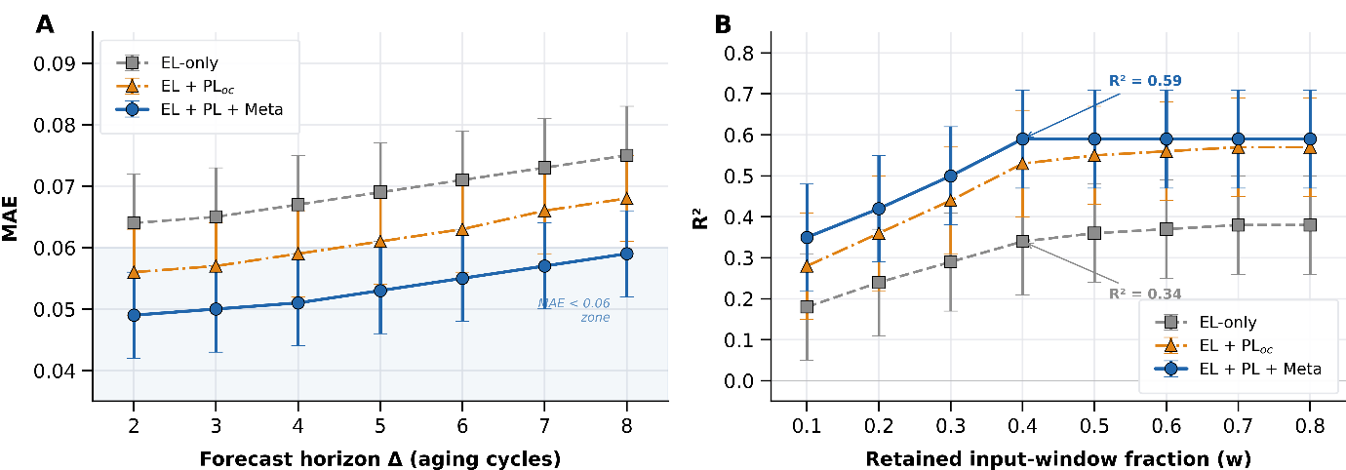
Figure 6 Early-time forecasting performance as a function of forecast horizon and retained input window. (A) Mean absolute error versus forecast horizon Δ (aging cycles, 2–8) for EL-only (dashed squares), EL + PLₒᴄ (triangles), and full multimodal (solid blue circles). (B) R² score versus fraction of trajectory retained (w = 0.2–0.8) for the same three configurations. Error bars represent 95% bootstrap confidence intervals (B = 2,000). All evaluations were performed on the held-out test set.

3.6 Explainability Analysis
Spatial attribution via Grad-CAM localized predictive relevance to physically plausible regions of the active area. Figure 7A presents representative Grad-CAM overlays for two held-out test-set devices. Sample A (measured Rₑₒₒ = 0.82, predicted Rₑₒₒ = 0.81; absolute error = 0.01) exhibited the highest attribution in the EL overlay at device edges and contact-adjacent regions, whereas the PLₒᴄ and PLₛᴄ overlays highlighted interior quench sites with mottled non-uniformity. Sample B (measured Rₑₒₒ = 0.91, predicted Rₑₒₒ = 0.89; absolute error = 0.02) showed more diffuse attribution centered on emerging but less advanced degradation zones, with the EL overlay concentrated near the cell periphery and the PL overlays distributed more broadly. These spatial patterns were consistent with known perovskite degradation morphologies—edge ingress, contact-proximal darkening, and localized quenching—but it should be emphasized that Grad-CAM identifies predictive correlates rather than causal degradation mechanisms.
Figure 7B presents the SHAP-derived scalar feature importance ranking for the handcrafted + metadata features evaluated on the full held-out test partition. Dark-area fraction was the most influential variable, with a mean absolute SHAP value of 0.27, followed by intensity variance at 0.21 and texture entropy at 0.15. Elapsed time contributed a mean absolute SHAP value of 0.12, and batch identifier contributed only ≈3 × 10⁻², representing a negligible impact on model output. This ordering demonstrated that heterogeneity-related spatial descriptors carried substantially more predictive weight than either global brightness or contextual metadata. The very low SHAP contribution of batch identifier further supported the conclusion from Section 3.1 that batch identity did not serve as a dominant confound or leakage pathway. The agreement between image-level attribution (Grad-CAM highlighting edges and quench sites) and feature-level attribution (SHAP emphasizing dark-area fraction and variance) strengthened the interpretation that the forecasting model was driven by spatially resolved defect morphology rather than by arbitrary visual correlations or dataset-level shortcuts.
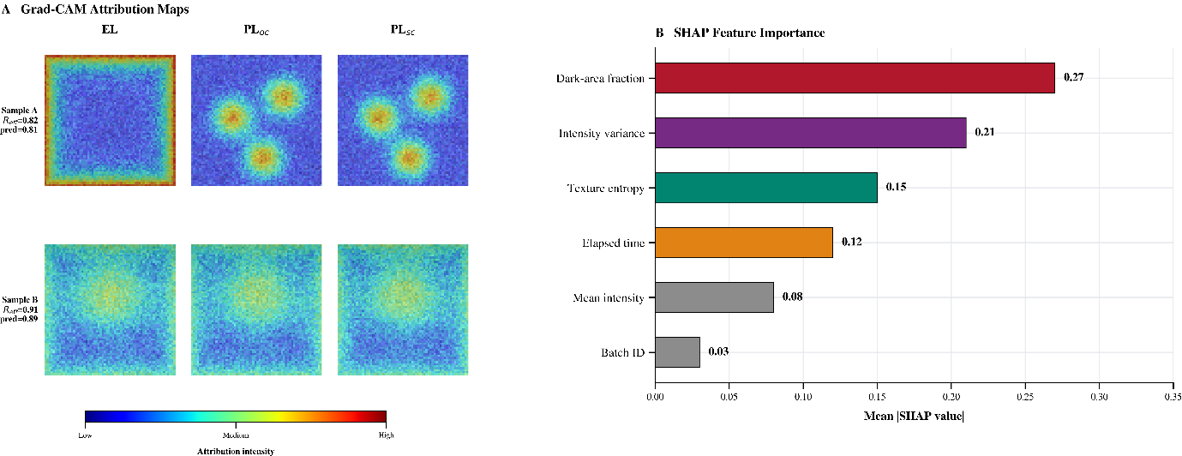Figure 7 Explainability analysis of the multimodal degradation forecasting model. (A) Spatial attribution maps (Grad-CAM overlays) for two representative test-set devices: Sample A (measured Rₑₒₒ = 0.82, predicted = 0.81) and Sample B (measured Rₑₒₒ = 0.91, predicted = 0.89), showing EL, PLₒᴄ, and PLₛᴄ overlays. Warmer colors indicate higher attribution. (B) SHAP feature importance ranking for scalar and metadata features (mean absolute SHAP value, computed via KernelExplainer on the full held-out test partition). Annotated values: dark-area fraction = 0.27, intensity variance = 0.21, texture entropy = 0.15, elapsed time = 0.12, batch ID ≈ 3 × 10⁻².

3.7 Cross-Architecture Generalization (Batch 2 Domain Shift)
Because Batch 2 (Architecture B; n = 17 devices, 516 forecast pairs) was held out entirely from training and comprised a distinct perovskite composition and contact configuration, its performance served as a dedicated domain-shift evaluation. Figure 8B presents the batch-wise MAE comparison. The intensity baseline exhibited the widest batch-to-batch spread, with MAE values of 0.071 (Batch 0, n = 20), 0.066 (Batch 1, n = 22), and 0.078 (Batch 2, n = 17)—a range of 0.012. The EL-only model showed reduced variation: MAE values of 0.063, 0.059, and 0.061 (range = 0.004). The EL + PL + metadata model achieved the lowest and tightest range, with MAE values of 0.049, 0.047, and 0.051 across the three batches (range = 0.004).
The Batch 2–specific MAE of the full model (0.051) exceeded the within-pool best (0.047 for Batch 1) by only 0.004, indicating that the multimodal representation preserved a comparatively uniform error profile despite the architectural domain shift. However, this result should be interpreted with appropriate caution: Batch 2 comprised only 17 devices, and the composition difference, while real, may not capture the full range of architectural variability encountered across the broader perovskite device landscape. The batch-wise analysis therefore supported within-corpus cross-architecture generalization but did not, by itself, establish universal architecture-independent performance.

3.8 Robustness across Folds, Batches, and Horizons
Robustness was evaluated along three axes—fold-level stability, batch-level generalization, and temporal horizon stability—as presented in the three panels of Figure 8. Across the four held-out cross-validation folds (Figure 8A), the intensity baseline produced highly variable R² values of −0.35, −0.08, 0.36, and 0.61, indicating strong sensitivity to split composition and occasional failure to outperform a constant predictor. The EL-only model was more stable, with fold-wise R² values of 0.21, 0.29, 0.43, and 0.34 (range = 0.22). The EL + PL + metadata model showed the most consistent behavior, with fold-wise R² values of 0.43, 0.51, 0.65, and 0.62 (range = 0.22; all positive; minimum = 0.43). The progression from negative or near-zero values in the baseline to uniformly positive values in the full model demonstrated that multimodal spatial learning reduced sensitivity to device-level heterogeneity in the training pool.
Robustness against forecast horizon (Figure 8C) further separated the models. For the intensity baseline, test R² decreased from 0.20 at Δ = 2 to −0.12 at Δ = 8, crossing into negative territory at approximately Δ = 6. The EL-only model remained positive but declined from 0.39 to 0.15 over the same range. The EL + PL + metadata model retained the strongest horizon stability, decreasing from 0.58 to 0.31 while remaining positive throughout. The slower decline in explained variance demonstrated that multimodal fusion not only improved accuracy at short horizons but also delayed performance breakdown as temporal extrapolation became more severe.
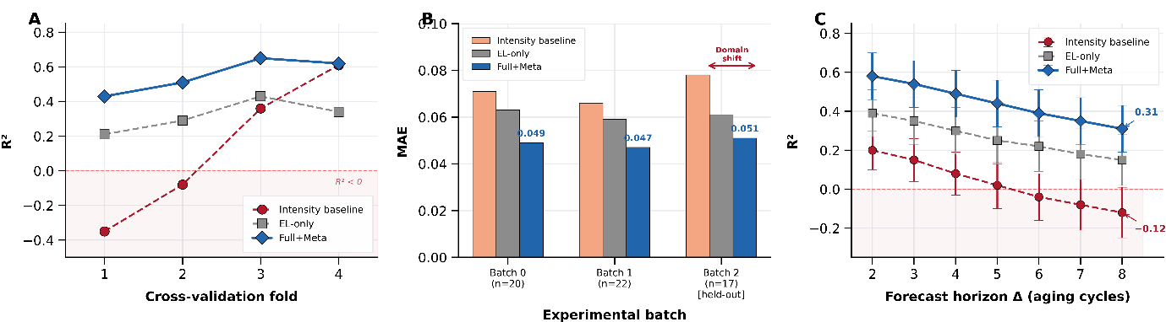
Figure 8 . Robustness of degradation forecasting across three evaluation axes. (A) Fold-level robustness: cross-validation R² across four held-out folds for the intensity baseline (red dashed), EL-only (gray dashed with squares), and full multimodal (black solid with circles). (B) B₂ domain generalization: batch-wise MAE for Batch 0 (n = 20), Batch 1 (n = 22), and Batch 2 (n = 17, held-out architecture). (C) Temporal stability: test R² versus forecast horizon Δ (2–8 aging cycles) for the same three model tiers. Error bars represent 95% bootstrap confidence intervals.

3.9 Residual Analysis and Failure Cases
To assess prediction calibration, residuals (yᵢ − ŷᵢ) of the full EL + PL + metadata model were examined across the held-out test set (n = 516 forecast pairs). The mean residual was −0.003 (95% CI [−0.011, 0.005]), indicating negligible systematic bias. The residual distribution was approximately symmetric, with a slight positive tail suggesting that the model occasionally under-predicted retained efficiency for devices that degraded more slowly than the training-set average. The Pearson correlation between absolute residual and true Rₑₒₒ was r = −0.31 (p < 0.001), indicating that larger prediction errors tended to occur for devices with lower retained efficiency (i.e., more severely degraded devices). This trend was consistent with the observation that extreme degradation events were rarer in the training corpus and therefore less well represented during model optimization.
Three systematic failure patterns were identified by inspecting the ten highest-error test-set predictions. First, devices exhibiting abrupt, catastrophic efficiency collapse (Rₑₒₒ < 0.60) between consecutive measurement cycles were poorly predicted, because the early luminescence images lacked precursor signatures of sudden failure. Second, devices with the dominant degradation mode being electrode delamination rather than absorber-layer deterioration showed elevated errors, likely because the luminescence images captured absorber-level changes more readily than contact-layer mechanical failure. Third, a small subset of Batch 2 devices with atypically high initial efficiency exhibited larger residuals, suggesting that the retained-efficiency normalization (Equation 2) amplified small absolute changes into large relative shifts for these outliers. These failure cases indicated that the current framework was most reliable for gradual, spatially distributed degradation and was less suited to sudden catastrophic or mechanically dominated failure modes.
- DISCUSSION
4.1 Spatial Heterogeneity as the Dominant Predictive Signal
The central finding of this study is that degradation forecasting in perovskite solar cells is governed primarily by spatially resolved luminescence heterogeneity rather than by global signal decay. The transition from handcrafted and intensity-based baselines (R² = 0.052–0.136) to single-modality convolutional models (R² = 0.287–0.317) produced a marked gain in explained variance, indicating that predictive information was concentrated in local non-uniformities that emerged before substantial average intensity loss occurred. This observation was corroborated by the Grad-CAM attribution maps (Figure 6A), which repeatedly highlighted edge darkening, contact-adjacent collapse, and localized interior quenching rather than uniformly dimmed regions. It was further supported by the SHAP feature ranking (Figure 6B), in which dark-area fraction (mean |SHAP| = 0.27) and intensity variance (0.21) substantially outweighed mean intensity (0.08) as predictive contributors.
This pattern is physically plausible. Perovskite degradation under continuous illumination and bias stress is known to initiate at spatially localized sites—grain boundaries, compositional inhomogeneities, edge-exposed regions, and contact-proximal interfaces—before propagating across the active area. The forecasting task therefore depends on identifying where degradation begins and how it evolves spatially, not merely on measuring how bright the device remains on average. However, it should be noted that the Grad-CAM and SHAP analyses identify predictive correlates rather than establish causal mechanisms of degradation. The spatial patterns highlighted by attribution may coincide with known failure modes, but this coincidence does not prove that the model has learned the underlying physical process. Independent characterization (e.g., cross-sectional microscopy or time-of-flight secondary ion mass spectrometry) would be required to confirm whether the attributed regions correspond to specific material-level degradation pathways.
4.2 Evidence for Cross-Modal Complementarity
The multimodal comparison indicated that EL and PL contributed complementary but non-identical information to the forecasting task. The modest difference between EL-only (R² = 0.317) and PL-only (R² = 0.287) performance suggested that each channel independently captured a substantial portion of the degradation state. However, the much larger gain upon fusion (EL + PL: R² = 0.526; ΔR² = 0.209 relative to EL-only, 95% CI [0.10, 0.32]) demonstrated that neither modality was sufficient on its own. This complementarity was further supported by the sub-modality ablation (Figure 4), which showed that PL_oc and PL_sc each contributed non-redundant information: bimodal combinations consistently outperformed any single modality, while the full trimodal configuration outperformed all bimodal pairs.
Several physical mechanisms may underlie this complementarity. EL imaging probes electrically driven recombination under carrier injection and is therefore sensitive to local variations in injection efficiency, series resistance, and contact quality. PL imaging at open circuit probes the balance between radiative and non-radiative recombination under optical excitation, while PL at short circuit additionally reflects carrier extraction efficiency. Degradation that predominantly affects one pathway—for example, contact delamination, which reduces injection uniformity without immediately altering absorber-level recombination—may be visible in EL but not in PL, and vice versa. The fusion architecture can, in principle, learn to detect disagreement between modalities as an additional indicator of emerging instability. However, this interpretation remains inferential. A definitive demonstration of cross-modal complementarity would require modality-stratified attribution analysis or controlled experiments in which specific degradation modes are selectively induced and monitored across EL and PL channels.
The additional gain from metadata was comparatively small (ΔR² = 0.028 relative to EL + PL without metadata), and the metadata-only control baseline yielded R² = 0.01 (Section 3.1), confirming that batch identity and elapsed time did not encode an independent predictive signal. Metadata, therefore, acted as a contextual regularizer—refining decision boundaries defined by luminescence features—rather than as a primary information source. This finding has practical implications: in deployment scenarios where metadata are unavailable or unreliable, the EL + PL model (R² = 0.526) can still achieve most of the forecasting benefit without any auxiliary inputs.
4.3 Ruling Out Temporal and Contextual Confounds
A key concern in any longitudinal forecasting study is whether performance gains arise from genuine image-derived features or from trivial correlates such as elapsed time or batch-level confounds. The leakage-control baselines introduced in Section 3.1 were specifically designed to address this concern. The time-only linear regressor (R² = −0.08) and the metadata-only model (R² = 0.01) both failed to exceed the explanatory power of a constant predictor, establishing that the observed performance hierarchy—from intensity baselines through single-modality CNNs to the fused multimodal model—was not attributable to temporal progression or batch identity.
This result is reinforced by the SHAP analysis, in which batch identifier contributed a mean absolute SHAP value of only ≈3 × 10⁻², representing the smallest contribution among all evaluated features. Elapsed time contributed 0.12—higher than batch ID but substantially lower than the spatial heterogeneity features (dark-area fraction: 0.27; intensity variance: 0.21). Together, these controls and attribution analyses provide convergent evidence that the forecasting signal originated from image-derived spatial features rather than from dataset-structural shortcuts. Nevertheless, the possibility that more subtle forms of leakage—such as correlations between degradation trajectory shape and acquisition timing—could contribute to performance in larger or more complex datasets cannot be entirely excluded and should be monitored in future extensions of this framework.
4.4 Early-Time Forecasting and Practical Screening Implications
The early-time forecasting results are especially relevant for reliability screening workflows. The full model-maintained MAE below 0.060 even at the longest evaluated horizon (Δ = 8 aging cycles) and preserved positive R² across all horizon and input-window settings (Figure 5). By contrast, the intensity baseline rapidly lost explanatory power and became non-predictive (R² < 0) at Δ ≥ 6. This separation indicated that early luminescence measurements contained persistent signatures of future degradation, and that multimodal spatial representations could recover those signatures before severe electrical deterioration became visible.
The monotonic increase in R² with the retained input-window fraction w (Figure 5B) further suggested that degradation-informative features accumulated progressively during early aging. Notably, the multimodal configurations benefited more strongly from additional early-time context than the EL-only model, as evidenced by the widening gap between curves in Figure 5B. This amplification effect indicated that temporal enrichment enhanced cross-modal complementarity rather than merely refining a single-channel signal: as more time points became available, the fusion model could detect emerging disagreements between EL and PL responses that were not yet resolved in the earliest snapshots.
In practical terms, these findings support a two-stage screening strategy. In the first stage, multimodal luminescence imaging acquired during the initial 20–40% of a standard aging protocol could be used to rank devices by predicted future retention, flagging unstable candidates for targeted follow-up. In the second stage, only flagged devices would require extended characterization, substantially reducing the aggregate measurement burden. However, the quantitative thresholds for such a triage protocol (e.g., the MAE tolerance acceptable for pass/fail decisions) would need to be calibrated against application-specific reliability requirements and validated on independent device populations before operational deployment.
4.5 Degradation Classification and Threshold Sensitivity
The secondary classification task demonstrated that the same multimodal feature space supported ordinal risk stratification, with the full model achieving a macro-F1 of 0.67 and an AUROC of 0.81 (Table 5). The per-class analysis revealed that the severe degradation class (c = 2; F1 = 0.73) was most reliably identified, while the moderate class (c = 1; F1 = 0.59) was most challenging. This asymmetry was physically intuitive: severe degradation produces pronounced spatial signatures (large dark areas, strong edge collapse) that are readily distinguishable from the stable state, whereas moderate degradation occupies a narrow retention range (0.90–0.95) in which spatial patterns may not yet have differentiated sufficiently from early-stage variability.
The threshold sensitivity analysis indicated that macro-F1 varied by ±0.04–0.06 when the class boundaries were shifted by ±0.02 in retained efficiency. This moderate sensitivity suggested that the classification performance was not critically dependent on the exact threshold choice but could be refined for specific screening applications. In contexts where false negatives (missed unstable devices) carry higher cost than false positives, the threshold could be adjusted to increase recall for the severe class at the expense of precision in the moderate class.
- Conclusions
This work developed and evaluated a multimodal luminescence forecasting framework for early degradation prediction in perovskite solar cells, using 59 devices across three experimental batches, yielding 1,843 forecast pairs from synchronized electroluminescence, open-circuit photoluminescence, and short-circuit photoluminescence measurements. The fused EL+PL+metadata model reduced MAE by 26.2% and RMSE by 20.0% relative to the EL-only convolutional regressor, and paired bootstrap testing confirmed that the R² gain of 0.237 (95% CI [0.13, 0.35]) was statistically significant. Leakage-control baselines—a time-only linear regressor (R² = −0.08) and a metadata-only model (R² = 0.01)—verified that elapsed time and batch identity did not encode trivial target progression. Across four cross-validation folds the full model-maintained R² ≥ 0.43, whereas the intensity baseline dropped to −0.35 in its weakest fold. Batch-wise MAE for the held-out Architecture B partition (Batch 2, n = 17 devices) was 0.051, only 0.004 above the within-pool best, indicating that the multimodal representation partially transfers across perovskite compositions and contact configurations. The secondary classification task yielded a macro-F1 of 0.67 and an AUROC of 0.81 for three-class degradation risk stratification. The per-class F1 reached 0.73 for severe degradation (c = 2) but only 0.59 for the moderate class (c = 1), reflecting the difficulty of resolving borderline retention values between 0.90 and 0.95. These results establish that spatially resolved multimodal luminescence patterns encode persistent degradation signatures detectable within the first 20–40% of a standard aging protocol. Future investigations will extend this framework to thermography-inclusive inputs, vision-transformer encoders, Sn-based and all-inorganic compositions, and outdoor field-aging datasets to evaluate transferability under environmental cycling and mechanical stress conditions.

Conflict of Interest Statement:
The author(s) declared no potential conflicts of interest.

Funding Declaration:
No financial support was provided.

Data Availability
The datasets used during the current study are available from the corresponding author on reasonable request.

References
Barletta, G., Ternes, S., Ali, S., Abbas, Z., Ostendi, C., D’Addio, M., Magliano, E., Asinari, P., Chiavazzo, E., & Di Carlo, A. (2026). Quantifying perovskite solar cell degradation via machine learning from spatially resolved multimodal luminescence time series. arXiv:2603.12857.
Baumann, S., Eperon, G. E., Virtuani, A., Jeangros, Q., Kern, D. B., Barrit, D., Schall, J., Nie, W., Oreski, G., Khenkin, M., Ulbrich, C., Peibst, R., Stein, J. S., & Köntges, M. (2024). Stability and reliability of perovskite containing solar cells and modules: Degradation mechanisms and mitigation strategies. Energy & Environmental Science, 17, 7566–7599. https://doi.org/10.1039/D4EE01898B
Bui, A. D., Nguyen, D.-T., Fell, A., Catchpole, K. R., Macdonald, D., & Nguyen, H. T. (2023). Spatially resolved power conversion efficiency for perovskite solar cells via bias-dependent photoluminescence imaging. Cell Reports Physical Science, 4(11), 101641. https://doi.org/10.1016/j.xcrp.2023.101641
De la Asunción-Nadal, V., Sprague, C. I., Guijarro-Berdiñas, B., Cappel, U. B., & García-Fernández, A. (2025). Machine learning for perovskite solar cells: A review on opportunities and challenges for materials scientists. EES Solar, 1, 927–957. https://doi.org/10.1039/D5EL00041F
Harth, M., Kumar, D. K., Kassou, S., El Idrissi, K., Gupta, R. K., Daniel, Y., Makdasi, O., Visoly-Fisher, I., & Gagliardi, A. (2025). Comparative convolutional neural networks for perovskite solar cell PCE predictions. npj Computational Materials, 11, 251. https://doi.org/10.1038/s41524-025-01744-w
Kumar, J., Nath, B., Bhattacharjee, T., & Ramamurthy, P. C. (2025). Machine learning aided optoelectric characterization modelling and prediction of the IV parameters of perovskite solar cells with >90% accuracy. Scientific Reports, 15, 30660. https://doi.org/10.1038/s41598-025-93004-6
Mammeri, M., Bencherif, H., Dehimi, L., Hajri, A., Sasikumar, P., Syed, A., & AL-Shwaiman, H. A. (2024). Stability forecasting of perovskite solar cells utilizing various machine learning and deep learning techniques. Journal of Optics, 54, 930–938. https://doi.org/10.1007/s12596-024-01819-9
Matusz-Kalász, D., Bodnár, I., & Jobbágy, M. (2025). An overview of CNN-based image analysis in solar cells, photovoltaic modules, and power plants. Applied Sciences, 15(10), 5511. https://doi.org/10.3390/app15105511
Nguyen, K., Bui, A. D., Mayon, A. O., Nguyen, T., White, T., Truong, T., Ho-Baillie, A., Duong, T., Shen, H., Weber, K., Catchpole, K., Macdonald, D., & Nguyen, H. T. (2023). Correlative imaging of optoelectronic properties for perovskite solar cells via hyperspectral luminescence imaging. Cell Reports Physical Science, 4(10), 101585. https://doi.org/10.1016/j.xcrp.2023.101585
Yuan, Y., Yan, G., Dreessen, C., Rudolph, T., Hülsbeck, M., Klingebiel, B., Ye, J., Rau, U., & Kirchartz, T. (2024). Shallow defects and variable photoluminescence decay times up to 280 µs in triple-cation perovskites. Nature Materials, 23, 391–397. https://doi.org/10.1038/s41563-023-01771-2
Baumann, F., Raga, S. R., & Lira-Cantú, M. (2023). Monitoring the stability and degradation mechanisms of perovskite solar cells by in situ and operando characterization. APL Energy, 1, 011501. https://doi.org/10.1063/5.0145199
Chen, W., Zhang, Z., Mularso, K. T., Jo, B., & Jung, H. S. (2026). Smart exploration of perovskite photovoltaics: From AI driven discovery to autonomous laboratories. Advanced Energy Materials, 2506803. https://doi.org/10.1002/aenm.202506803
Kober-Czerny, M., Dasgupta, A., Seo, S., Rombach, F. M., McMeekin, D. P., Jin, H., & Snaith, H. J. (2025). Determining parameters of metal-halide perovskites using photoluminescence with Bayesian inference. PRX Energy, 4, 013001. https://doi.org/10.1103/PRXEnergy.4.013001
Wang, Z., Gao, H., Wu, D., Meng, J., Deng, J., & Cui, M. (2024). Defects and defect passivation in perovskite solar cells. Molecules, 29(9), 2104. https://doi.org/10.3390/molecules29092104
Wang, B., Wang, J., Li, L., & Wang, D. (2026). Data-driven AI approaches for screening high-efficiency, stable, and lead-free perovskite photovoltaic materials: A review. Frontiers in Materials, 12, 1669229. https://doi.org/10.3389/fmats.2025.1669229
Zhang, S., Ye, F., Wang, X., Chen, R., Zhang, H., Zhan, L., & Wu, Y. (2023). Minimizing buried interfacial defects for efficient inverted perovskite solar cells. Science, 380(6643), 404–409. https://doi.org/10.1126/science.adg3755
Meng, L., You, J., & Yang, Y. (2018). Addressing the stability issue of perovskite solar cells for commercial applications. Nature Communications, 9, 5265. https://doi.org/10.1038/s41467-018-07255-1
Ternes, S., Barletta, G., Ostendi, C., Di Carlo, A., & Chiavazzo, E. (2026). Multimodal luminescence time-series dataset for perovskite degradation [Dataset]. Zenodo. https://doi.org/10.5281/zenodo.14888839
Duan, L., Walter, D., Chang, N., Peng, J., Zhao, Y., Yao, N., Bui, A. D., Nguyen, H. T., Macdonald, D., & Catchpole, K. R. (2023). Stability challenges for the commercialization of perovskite–silicon tandem solar cells. Nature Reviews Materials, 8, 261–281. https://doi.org/10.1038/s41578-022-00521-1
Li, Z., Klein, T. R., Kim, D. H., Yang, M., Berry, J. J., van Hest, M. F. A. M., & Zhu, K. (2018). Scalable fabrication of perovskite solar cells. Nature Reviews Materials, 3, 18017. https://doi.org/10.1038/natrevmats.2018.17

